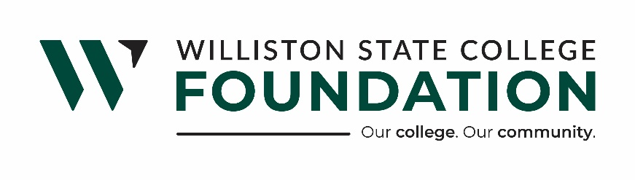

WSC FOUNDATION BOARD OF DIRECTORS REGULAR MEETING
MINUTES
721 E. HIGHLAND DR. SUITE D | November 18, 2025 |11:30 a.m.

WSC Foundation Mission Statement:

Williston State College Foundation is dedicated to advancing the college’s mission by securing financial support and fostering meaningful connections with alumni, donors, and the surrounding communities.

Present: Board Members: Lee Murphy, Melanie Stillwell, Katie Kringen, Bill Gathman, Sara Solberg, Bill Carl, Jackie Sorenson, and Taylor Olson.
WSCF Staff: Executive Director, Hunter Berg, and Donor Relations and Community Outreach Coordinator, Kristina Kitchens

Absent: Board Members: Lance Olson, Brandon Johnson, Mark Barstad, Chief Financial Officer Laurie Furuseth

President Taylor Olson called the meeting to order at 11:32 pm.

A motion to accept Bill Carl and Sara Solberg as new board members was made by Director Lee Murhpy, seconded by Director Melanie Stillwell. Motion carried.

A motion to accept Taylor Olson as president, Lee Murphy as vice president, and Katie Kringen as treasurer was made by Director Melanie Stillwell, seconded by Director Jackie Sorenson. Motion carried.

A motion to accept the committee assignments as presented was made by Director Bill Gathman, seconded by Director Melanie Stillwell. Motion carried.

Motion to approve the Consent Agenda as follows made by Director Lee Murphy and seconded by Director Melanie Stillwell. Motion carried.

- Consent Agenda:
- Minutes dated Oct 21st, 2025

Motion to approve the Financial Statements as follows, made by Katie Kringen and seconded by Director Lee Murphy. Motion carried.

- Financial Statements
  - Williston State College Foundation
  - WSC Supporting Foundation
  - WSC Housing LLC
  - WSC Charitable Gaming
- Updates:

Dr. Hirning, WSC President, Update
- New banners down University Ave.
- NDSU President update.
- Valley City State University update.
- Athletics update.
- Healthcare Training Facility Update
- Jan 12th, 2026 classes start in the new healthcare building.
- Legislative Committee update.

CFO, Laurie Furuseth Update:
- No Update
Donor Relations and Community Outreach Update:
- WSC Foundation Board Christmas party is December 16th at 6:00. Bring a $20 or under white elephant gift.
Hunter Berg, WSCF Executive Director, Update:
- Imm – Apartment update
- Healthcare Training Facility fundraising update.
- Jane Nelson Trust update
- Hunter will gather more information regarding Dave Anfinson’s brewing idea.

Old Business:
- None

New Business:
- Director Lee Murphy motioned to accept the gaming grant requests from Close Up, the Drill Team, and the Parks and Rec for the Ballen in the Basin Tournaments, seconded by Director Bill Gathman. Motion carried.

Respectfully submitted,

Hunter Berg
Executive Director

